DSBDA Assignment 4

Data Analytics - 1

Create a linear Regression Model using Python to predict home prices using California Housing Dataset. The California Housing dataset contains information about various houses in California through different parameters. There are 506 samples and 14 feature variables in this dataset.

This objective is to predict the value of prices of the house using the given features.

Import Required libraries, data.

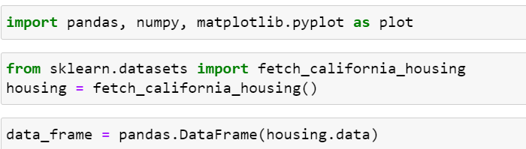

Converting data from nd-array to data frame and adding feature names to the data

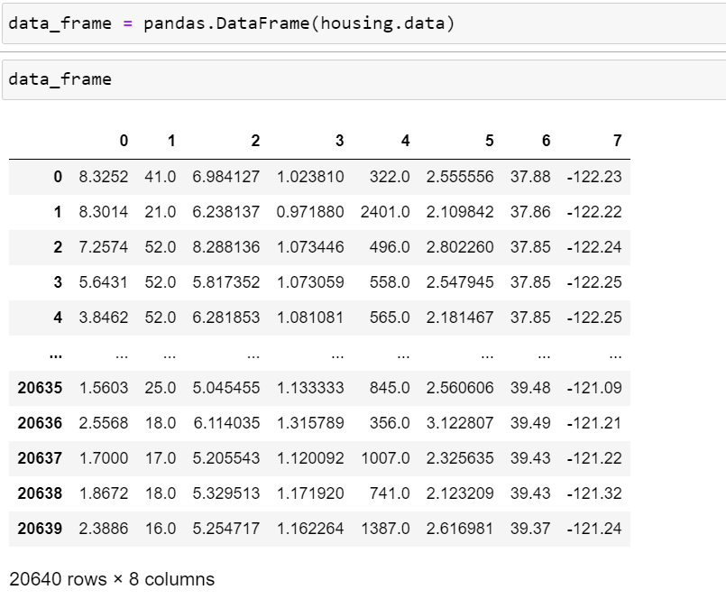

Getting Input and output data and further splitting data to training and testing dataset.

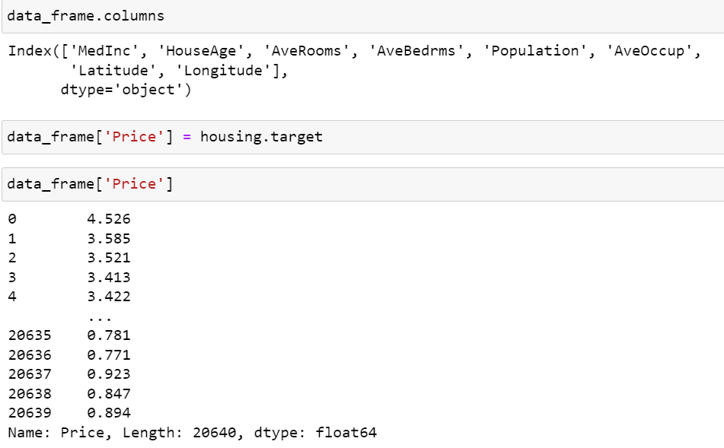

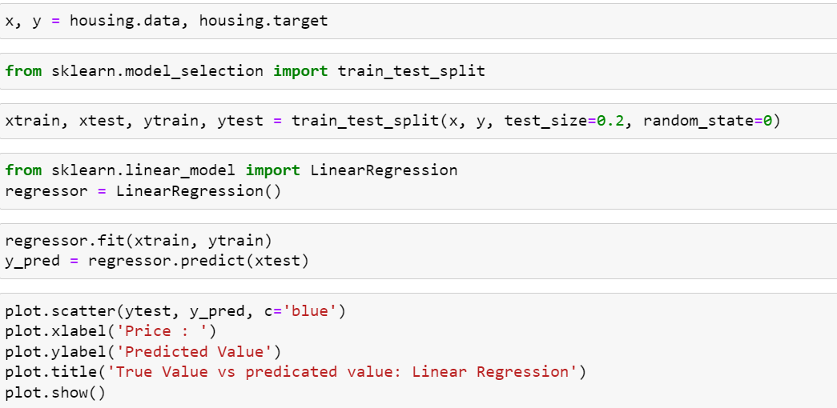

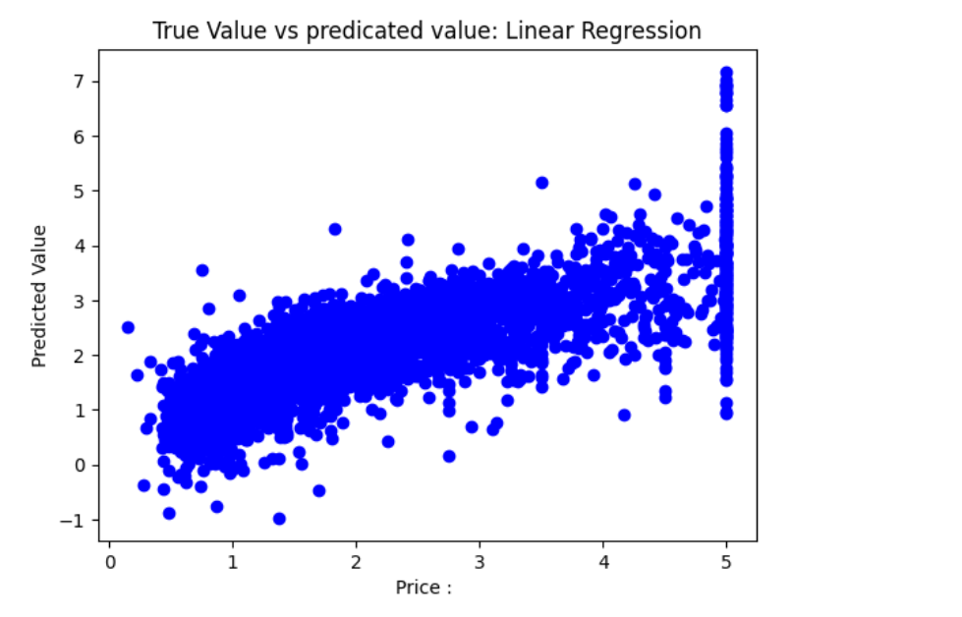

Calculating Error:-

